Activation Report
ASAP 7.0.2 – WASS1133, JAMU66
ASAP-ORIGIN

Accumulated from week 33 to week 35

September 04th, 2018

Contents

1 Activation Orders: JAMU66 Originated by CIS 3
1.1 JAMU66 Service Orders 3
1.2 Activation Orders Origin Distribution 4
2 Activation Orders: WASS1133 Originated by CIS 5
2.1 WASS1133 Service Orders 5
2.2 Activation Orders Origin Distribution 6

Activation Orders: JAMU66 Originated by CIS

JAMU66 Service Orders

ORIGINATING CIS | TOTAL | PERCENTAGE | COMPLETE | FAILED | TIMEOUT
CIS_JAMAICA | 129083 | 71.42% | 107965 | 20098 | 1020
CIS_CAYMAN | 9611 | 5.32% | 8961 | 650 | 0
CIS_ANTIGUA | 2954 | 1.63% | 2840 | 114 | 0
CIS_ANGUILLA | 1256 | 0.69% | 1229 | 27 | 0
CIS_BARBADOS | 10582 | 5.85% | 10186 | 396 | 0
CIS_BVI | 5678 | 3.14% | 5664 | 14 | 0
CIS_DOMINICA | 3251 | 1.80% | 3223 | 28 | 0
CIS_GRENADA | 3040 | 1.68% | 3026 | 14 | 0
CIS_MNI | 315 | 0.17% | 272 | 43 | 0
CIS_SANTA_LUCIA | 4582 | 2.54% | 4550 | 32 | 0
CIS_ST_KITTS | 2372 | 1.31% | 2333 | 39 | 0
CIS_SN_VINCENT | 3477 | 1.92% | 3468 | 9 | 0
CIS_TKI | 3659 | 2.02% | 2795 | 864 | 0
OCA | 792 | 0.44% | 668 | 123 | 0
INTEGSSOFT | 0 | 0.00% | 0 | 0 | 0
CIS_172_21_64_99 | 84 | 0.05% | 46 | 38 | 0
ASAP TEST | 0 | 0.00% | 0 | 0 | 0
 | 180736 |  | 157226 | 22489 | 1020

Activation Orders Origin Distribution

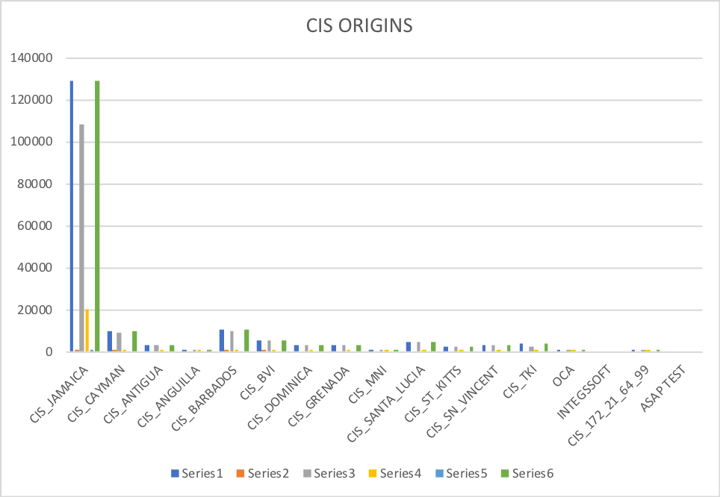

Activation Orders: WASS1133 Originated by CIS

WASS1133 Service Orders

ORIGINATING CIS | TOTAL | PERCENTAGE | COMPLETE | FAILED | TIMEOUT
CIS_JAMAICA | 55682 | 73.18% | 39024 | 10611 | 4759
CIS_CAYMAN | 0 | 0.00% | 0 | 0 | 0
CIS_ANTIGUA | 146 | 0.19% | 21 | 141 | 0
CIS_ANGUILLA | 1329 | 1.75% | 962 | 549 | 0
CIS_BARBADOS | 0 | 0.00% | 0 | 0 | 0
CIS_BVI | 3379 | 4.44% | 2318 | 900 | 0
CIS_DOMINICA | 1499 | 1.97% | 1004 | 730 | 3
CIS_GRENADA | 4929 | 6.48% | 4630 | 416 | 2
CIS_MNI | 142 | 0.19% | 124 | 9 | 1
CIS_SANTA_LUCIA | 2845 | 3.74% | 2713 | 52 | 78
CIS_ST_KITTS | 3209 | 4.22% | 2942 | 307 | 0
CIS_SN_VINCENT | 2466 | 3.24% | 2252 | 271 | 0
CIS_TKI | 429 | 0.56% | 159 | 176 | 2
OCA | 26 | 0.03% | 16 | 12 | 0
INTEGSSOFT | 1 | 0.00% | 1 | 0 | 0
CIS_172_21_64_99 | 12 | 0.02% | 9 | 3 | 0
ASAP TEST | 60 | 0.08% | -47 | 0 | 2108
 | 76094 |  | 56222 | 14177 | 2737

Activation Orders Origin Distribution

